|  |
| --- |
| **Project Report**  **SYSC 5708- Model-Driven Development of Real-Time and Distributed Software** |
| Fall 2014  Submitted To    Professor Dorina C. Petriu  By  **Ferhan Jamal (100 953 487)**  Carleton University |

**Table of Contents**

**1. Introduction**

**2. Problem Statement**

**3. Requirement Model**

**4. Analysis Model**

**4.1 Static Model**

**4.1.1 Problem Domain**

**4.1.2 System Context Diagram**

**4.1.3 Entity Class Diagram**

**4.1.4 Boundary Class Diagram**

**4.1.5 Preliminary Subsystem Decomposition**

**4.2 Dynamic Model**

**4.2.1 Sequence Diagrams**

**4.2.2 State-chart Diagrams**

**5. Design Model**

**6. Project Outcome**

**7. Limitations**

**1. Introduction**

Library Management System is online library management software which has arrived to handle entire functions in a library. It is user-friendly software and it has been designed by keeping in mind the general needs of the user.

The basic operations possible from the online library management system software which the old manual system cannot do are as follows:

1. Searching of books

2. Checking the availability of books

3. Issuing of books

4. Adding books/magazines and new users

5. Updating books/magazines and new users

6. Deleting books/magazines and new users

All of these above processes are very fast in the online library management system software. In the rest of the report, we will discuss how the working takes place in online library management system software through various UML diagrams. These UML diagrams are classified in the various steps:

1. Step 1
2. Step 2
3. Step 3

**2. Problem Statement**

Library Management System is an online management system. It has come in the picture due to some flaws in the manual system. In the old manual system there are various things which take a lot of amount of time and physical work. The examples of these things are as follows:

a. Books management was not so easy in the manual system.

b. Books availability is known only to the staff people in the manual system.

d. Preparing a list of defaulters sometimes becomes nightmare for the library staffs.

e. Report generation takes a lot of time in the old manual system.

f. The processes involved in the old manual system are time consuming and sometimes involve some error too.

**3. Requirement Model (Step 1)**

In the requirement modeling, we make a **use-case model** of the system. The use-case model basically involves the interaction between the actors and the system to achieve a goal. Here the system is Online Library Management System and the users involved here are Librarian and the user. The user can be students or faculty or any member accessing the library. The Use-case model of Library management system is as follows:

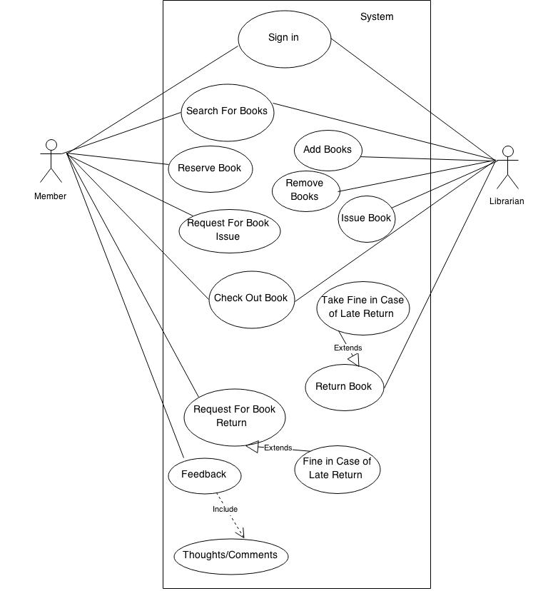

**Use-Case Model (Library Management System)**

The use-case involved with member and Librarian are as follows:

**Member:**

**1.** Sign in.

**2.** Search for Books.

**3.** Reserve Book.

**4.** Request for Book Issue.

**5.** Check out Book.

**6.** Request for Book Return (Fine in case of Late Return)

**7.** Feedback that includes thoughts or comments.

**Librarian:**

**1**. Sign in

**2**. Search for Books

**3**. Add Books

**4**. Remove Books

**5**. Issue Book

**6**. Return Book (Take fine in case of late return)

In the case of librarian, there are some access which are given to him not to the students or faculty.

.

**4. Analysis Model (Step 2)**

The analysis model comprises of the static and the dynamic model. The static model deals with structure of system whereas dynamic model deals with the behavior of a system. The static and dynamic model is then comprises of various things which are as follows:

**4.1 Static Model:**

**4.1.1** Problem Domain

**4.1.2** System Context Diagram

**4.1.3** Entity Class Diagram

**4.1.4** Boundary Class Diagram

**4.1.5** Preliminary Subsystem Decomposition

**4.2 Dynamic Model:**

**4.2.1** Sequence Diagrams

**4.2.2** State-chart Diagrams

**4.1.1 Problem Domain**

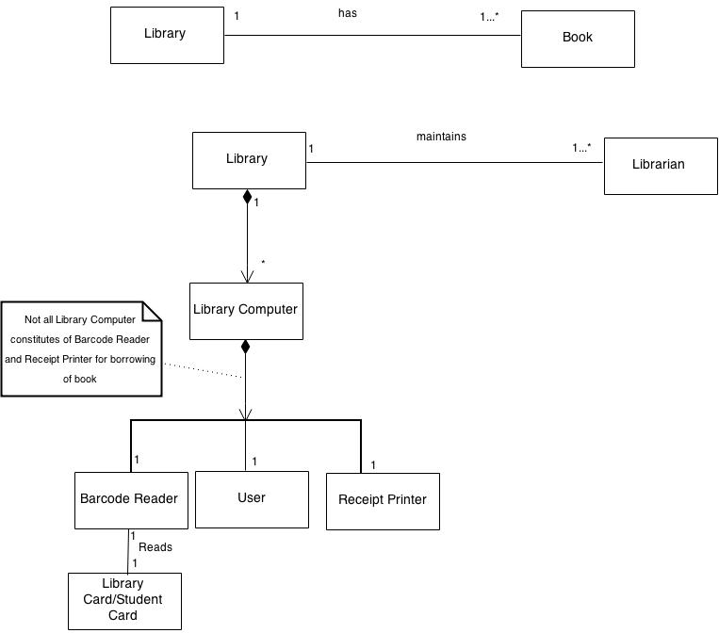

In the above diagram, we identify entity classes and their relationships. The entity classes are as follows:

**1.** Library

**2.** Librarian

**3.** Library Computer

**4.** Barcode Reader (Reads Library Card)

**5.** User

**6.** Receipt Printer

The library comprises of one to many librarian, computer and a book. The library computer is then composed of

1. Barcode Reader

2. User

3. Receipt Printer

The basic purpose of this diagram is to identify the physical classes and their relationships and also the external users which are involved in the system

**4.1.2 System Context Diagram**

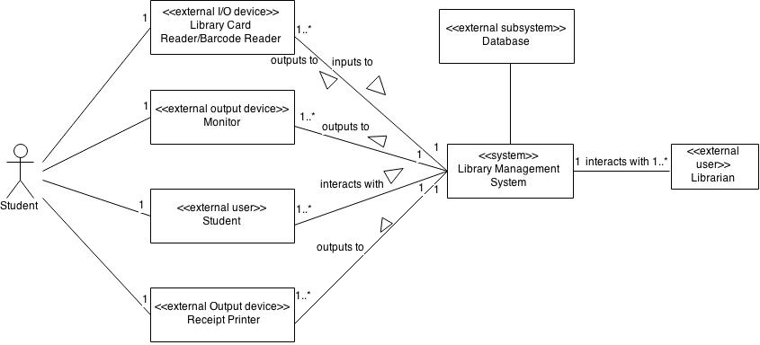

The system context diagram basically shows the interaction between the system to be designed and the environment. The environment here basically involves the external users and the external devices and the system here is the Library Management System The external input/output device - Library Card, external output device - Monitor, external user - student, and the external output device – receipt printer is showing the interaction with library management system. The library management system is then connected with an external database where all the records are kept

**4.1.3 Entity Class Diagram**

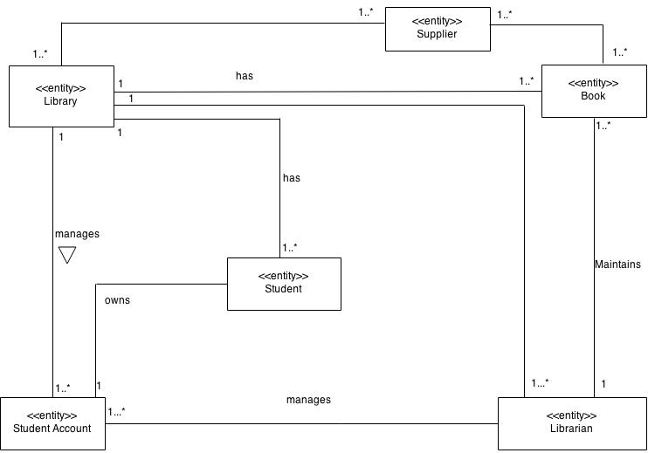

In the entity class diagram, the relationships between various entities are shown. Various entities used in the library management system are as follows:

1. Library

2. Book

3. Supplier

4. Student Account

5. Librarian

6. Student

**4.1.4 Boundary Class Diagram**

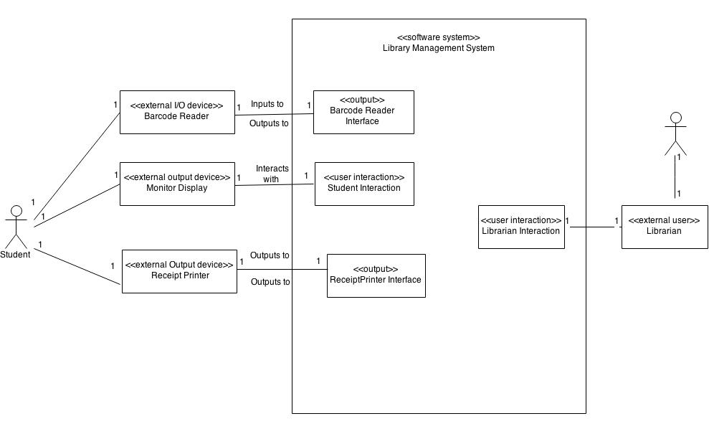

In the Boundary Class Diagram, the system is added with the boundary objects which is then surrounded with the external objects. The system here is the library management system and external objects and user here is:

1. Barcode Reader

2. Monitor Display

3. Receipt Printer

4. Librarian (External User)

**4.1.5 Preliminary Subsystem Decomposition**

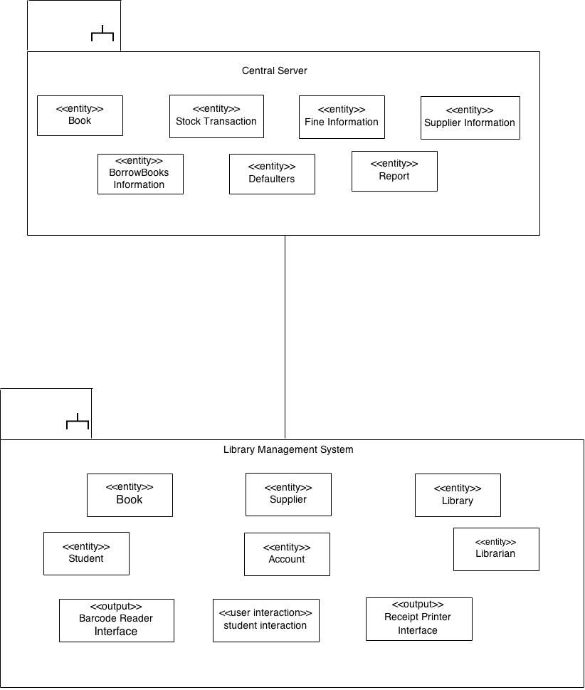

In the above preliminary subsystem decomposition diagram, the library management system is connected with the central server. The object of drawing this diagram is to decompose the systems. Both of these subsystems perform different functions and have specific entity classes and interfaces. The objects and interfaces present in both of them are as follows:

**Central Server:**

**1.** Book

**2.** Stock Transaction

**3.** Fine Information

**4.** Supplier Information

**5.** Borrow Books Information

**6.** Defaulters

**7.** Report

**Library Management System:**

**1.** Book

**2.** Supplier

**3.** Library

**4.** Student

**5.** Account

**6.** Librarian

**7.** Barcode Reader Interface

**8.** Student Interaction

**9.** Receipt Printer Interface

**4.2.1 Sequence Diagram (Borrow Use Case)**

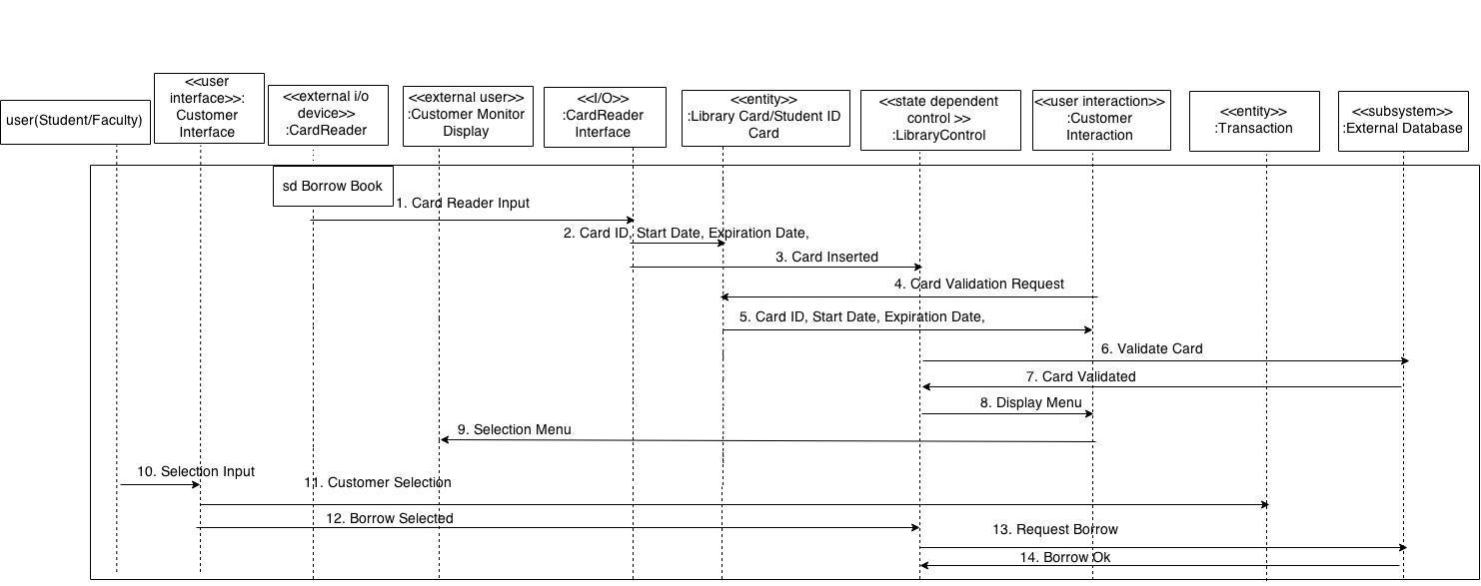

**4.2.2 State-chart Diagram(Borrow Use Case)**

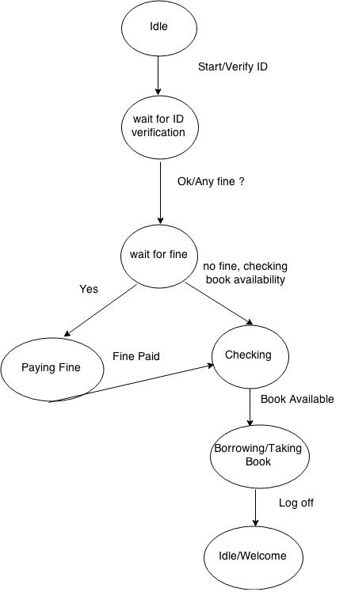

**5. Design Model**

In the design model we try to synthesize the software architecture from the analysis model. The software architecture can be distribution of subsystems and concurrency inside subsystems. The *concurrent* *collaboration* *diagram* explains the Designing part of the library management system. The diagram of it is given below:

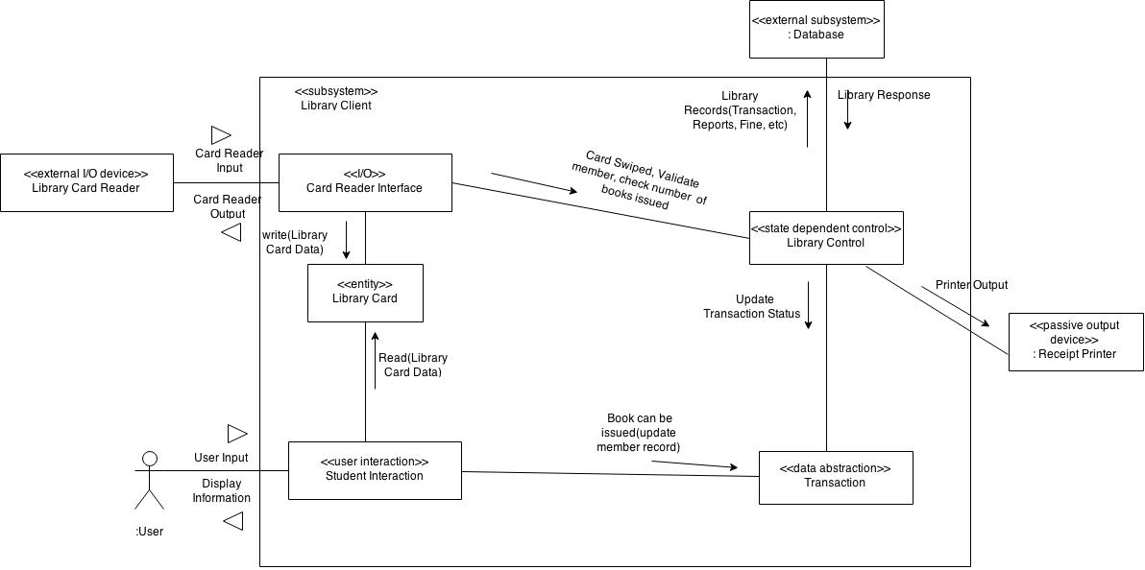

**Concurrent Collaboration Diagram**

**6.Project Outcome**

The project outcome of our library management system is to achieve the following four things:

1. To make present system more advanced and more fast.

2. To make the functions of library less complicated and work more faster

3. To make the library environment user-friendly and very much efficient to the users

4. To decrease the workload and make life easier for employees and users (student/faculty)

**7. Limitations**

1. It works with internet connection

2. The communication becomes negligible in the library environment

3. Budget is very high in building this system